**MIDDLETON CHENEY FOOTBALL CLUB ANNUAL GENERAL MEETING 2001**

**General Committee Meeting**

**July 19th 2001**

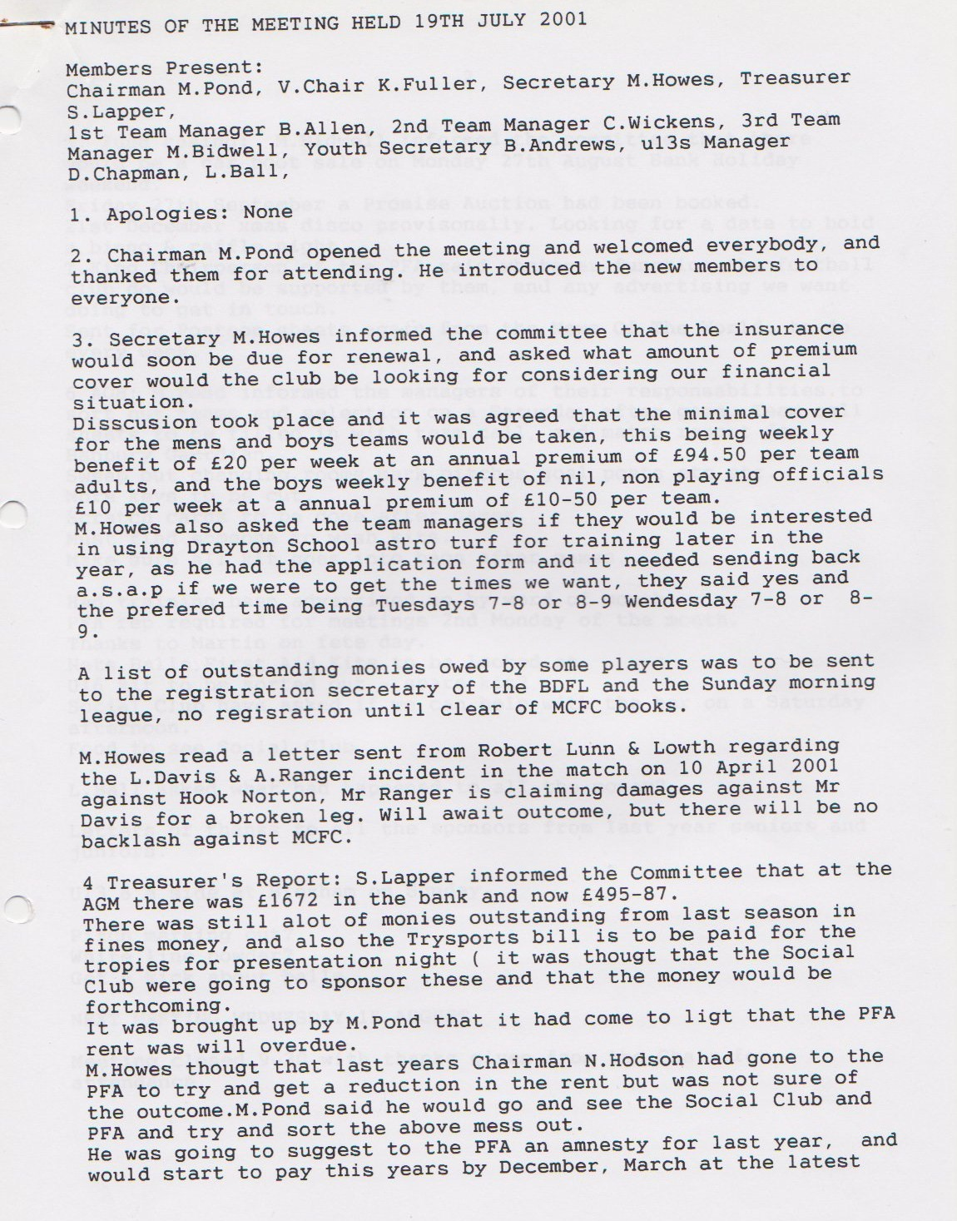

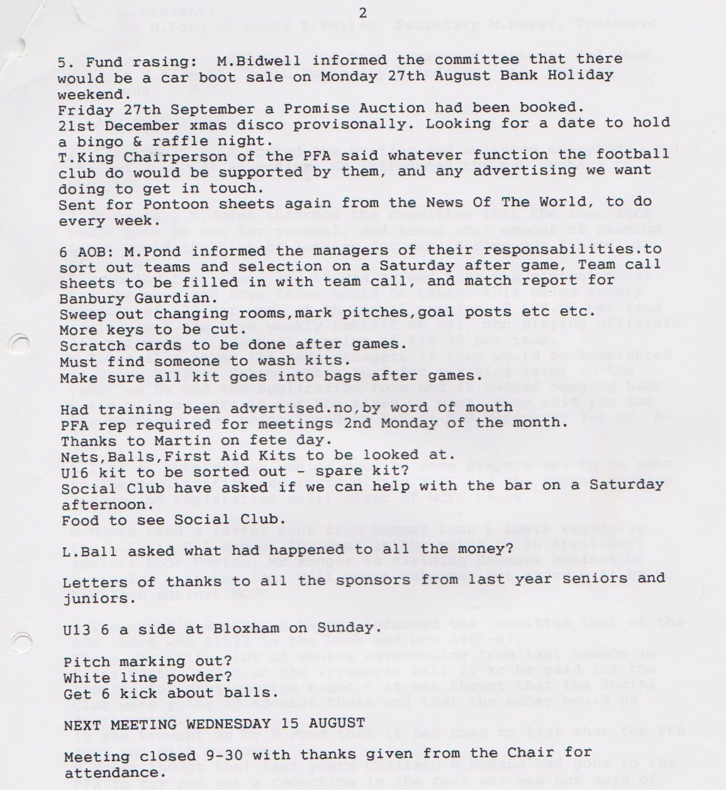

**General Committee Meeting**

**September 12th 2001**

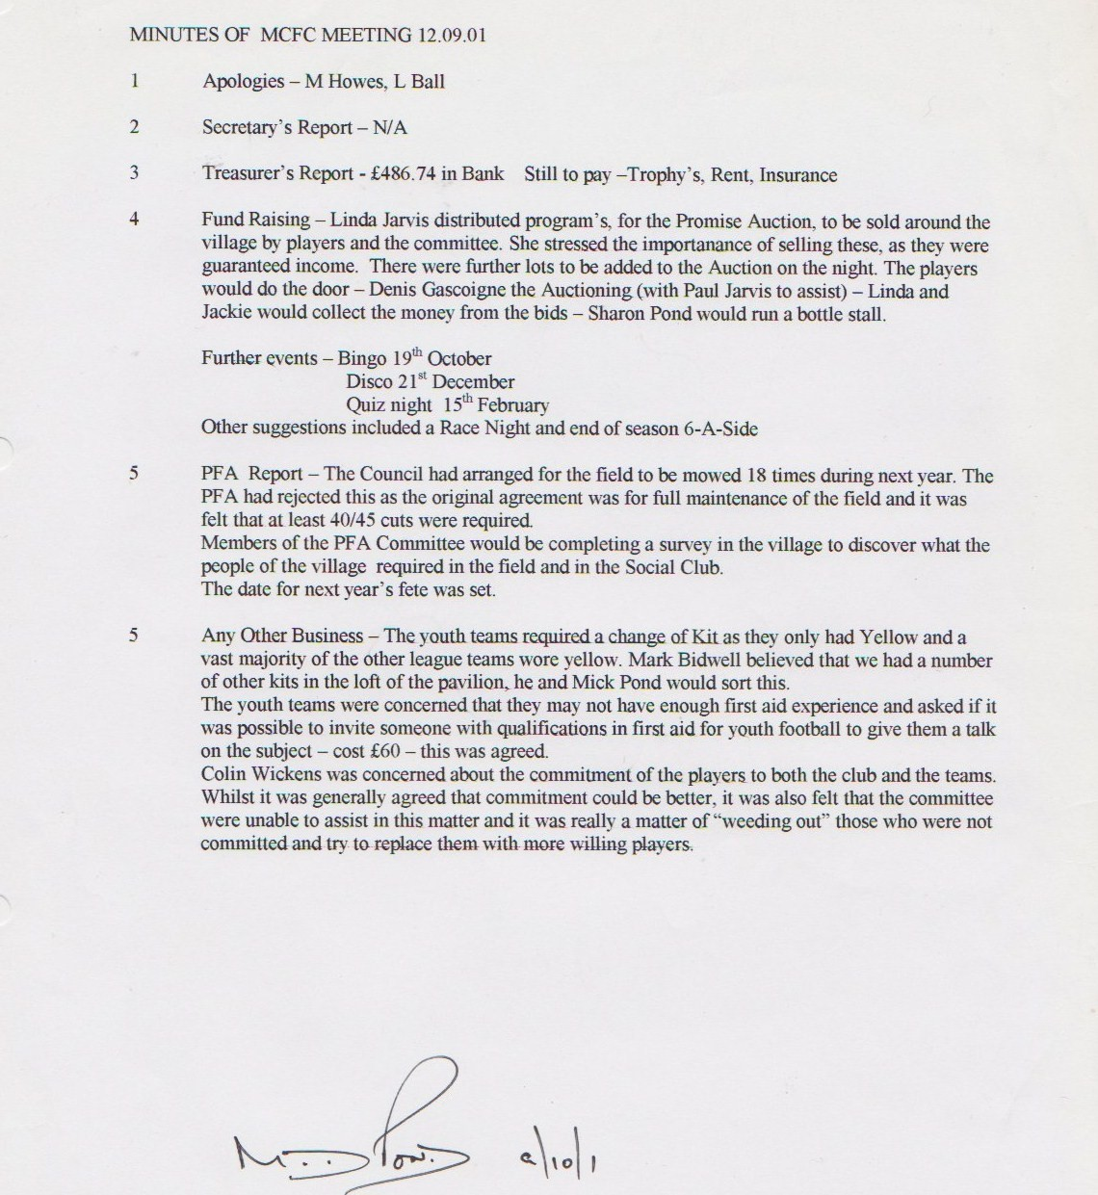

**General Committee Meeting**

**October 2001**

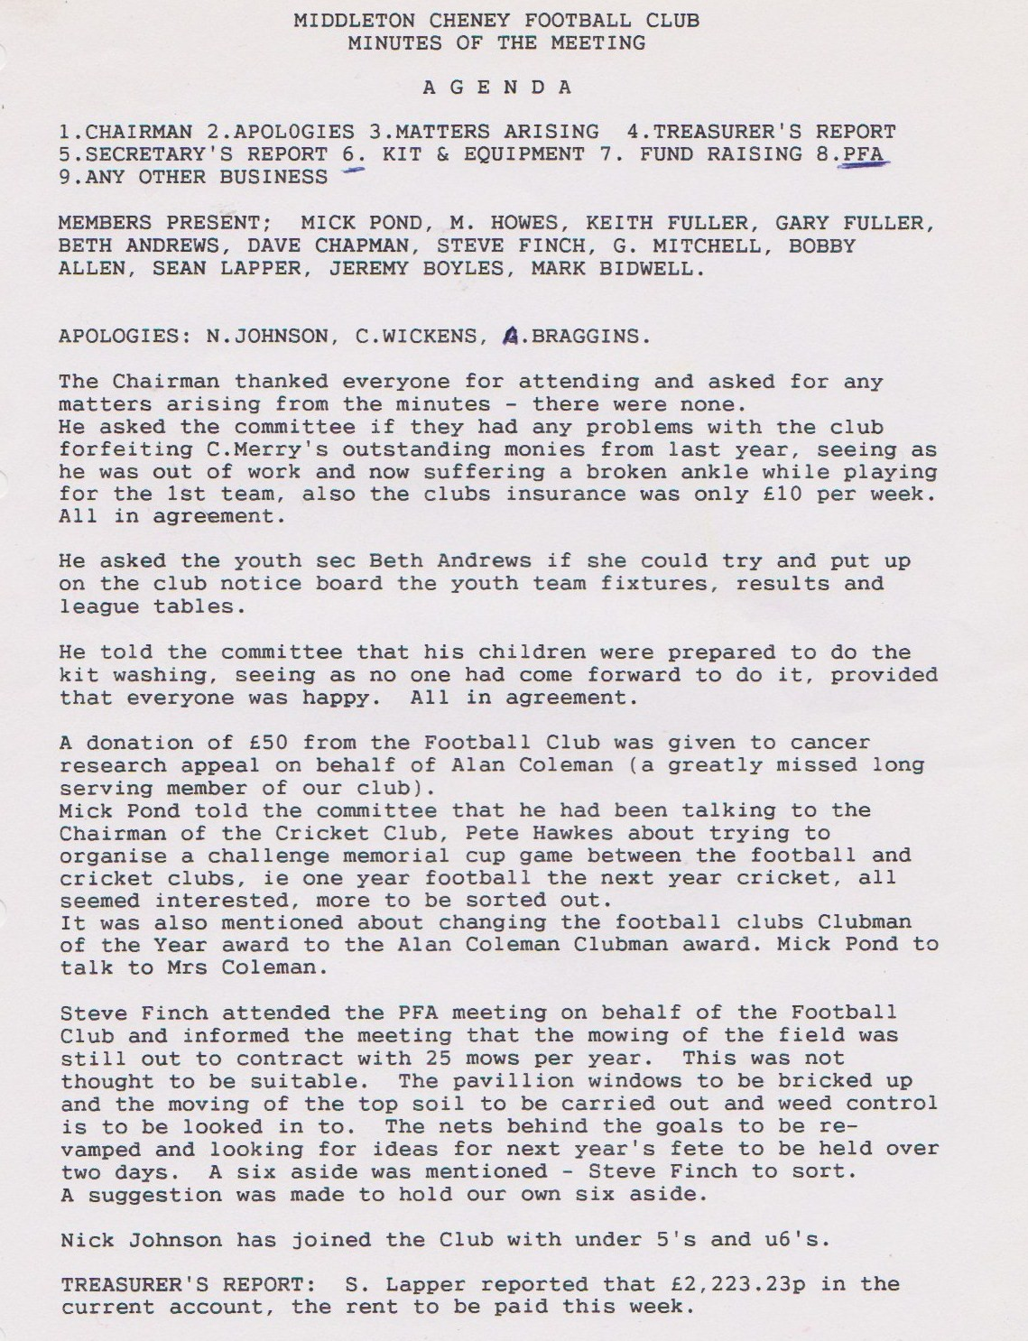

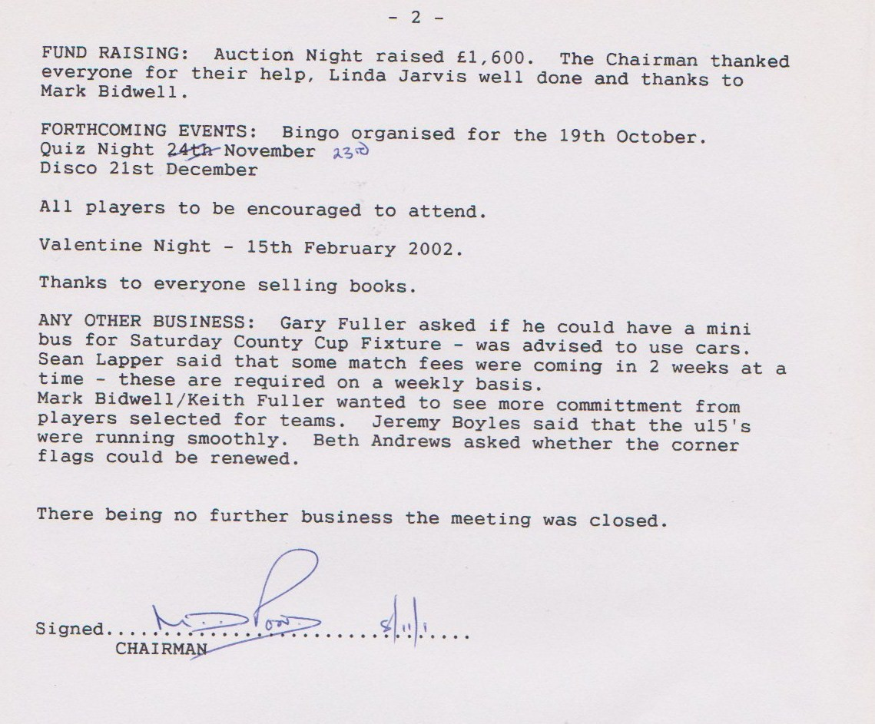

**General Committee Meeting**

**September 12th 2001**

